EXP 1:
1. Explain matrix addition, subtraction, multiplication, and transpose with suitable examples and state the conditions required for each operation.
2. Describe how two-dimensional arrays are used to represent matrices in C programming. Explain the process of accessing and manipulating matrix elements using nested loops.
3. Explain why compatibility between matrices is necessary before multiplication.
4. Discuss the applications of matrix operations in real-world domains such as computer graphics, image processing, machine learning, engineering, and scientific computing.
5. Explain the role of nested loops in implementing matrix operations in C. Illustrate how nested loops are used for addition, multiplication, and transpose of matrices.
Exp 2:
  - What is a sparse matrix? List the applications?
  - Represent sparse matrices with suitable data structures? Explain with an example simple and fast transpose?
  - Find out the addition of two sparse matrices in triplet form and also find Simple and Fast transpose?
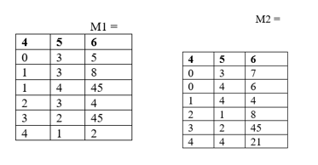
Exp 3:
- What is the meaning of database? How to maintain in C
- What are the applications of searching?
- Compare linear search and binary search?
- What are the applications of sorting?
- Compare and contrast, selection, insertion sort and shell sort?
- What is external & internal sorting, In-place, Stable Features of Sorting Algorithms?
EXP 8 : linear queue:
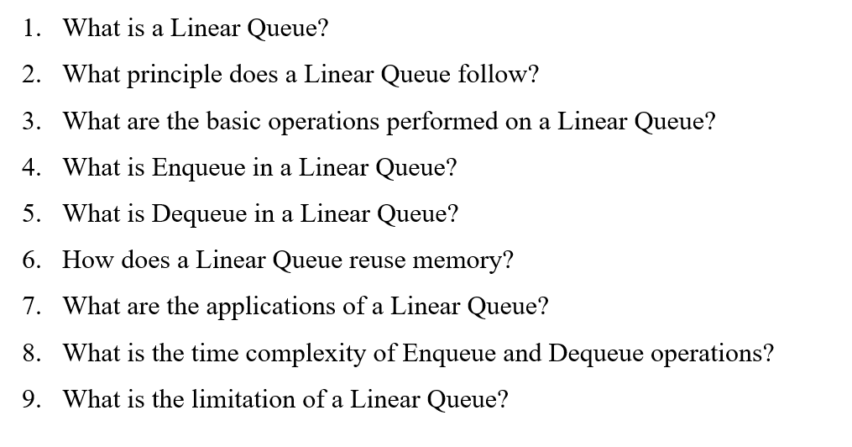
EXP 9 : circular queue:
